# i2b2 OntoImport Suite

Version #1 (01.02.2011) by Sebastian Mate

This package demonstrates the OWL-based i2b2 data import developed by Sebastian Mate in his Diploma thesis.

## i2b2 Installation

Install i2b2 by using the i2b2 Wizard (see ZIP file and refer to its documentation). In i2b2 Wizard, create a new i2b2 project (you should keep the default “My Project” for now), an i2b2 user, and assign the user to the project. Make sure that the created project is working by launching i2b2.

## OntoSuite Demo Workflow

Modify the settings in the file ExportConnection.properties to match the newely created i2b2 project and launch OntoGen.jar:

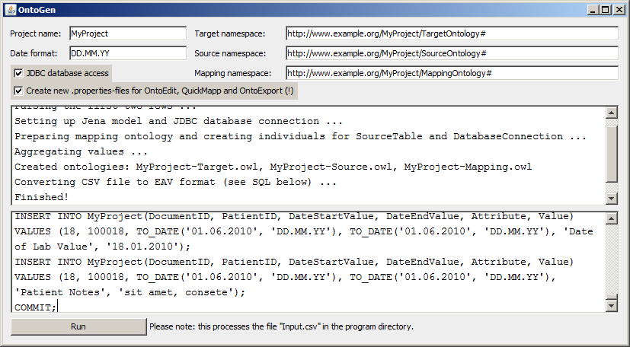

Check “JDBC database access” and “Create new.properties-files …”. There is no need to modify the “Project Name” setting as it is independent from the i2b2 project name.

Press “Run”. You can ignore JDBC errors which may appear because the program tries to delete a table which does not exist yet.

OntoGen creates the three ontologies (target, source and mapping) from the Input.csv file. The contents of the CSV file are converted into the EAV format and uploaded into a table into the i2b2 project schema. The table’s name matches the “Project Name” setting as specified in OntoGen (upper left corner):

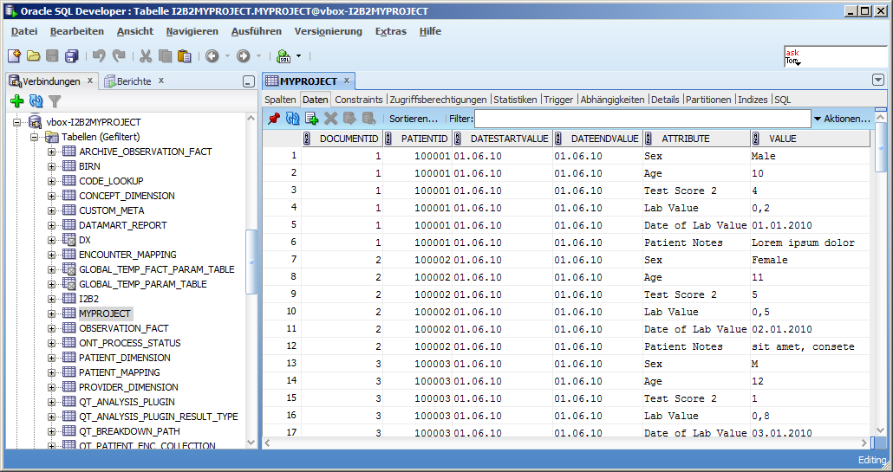

Next, run OntoExport.jar. Make sure that “Facts” and “JDBC database access” are checked, then press “Start”:

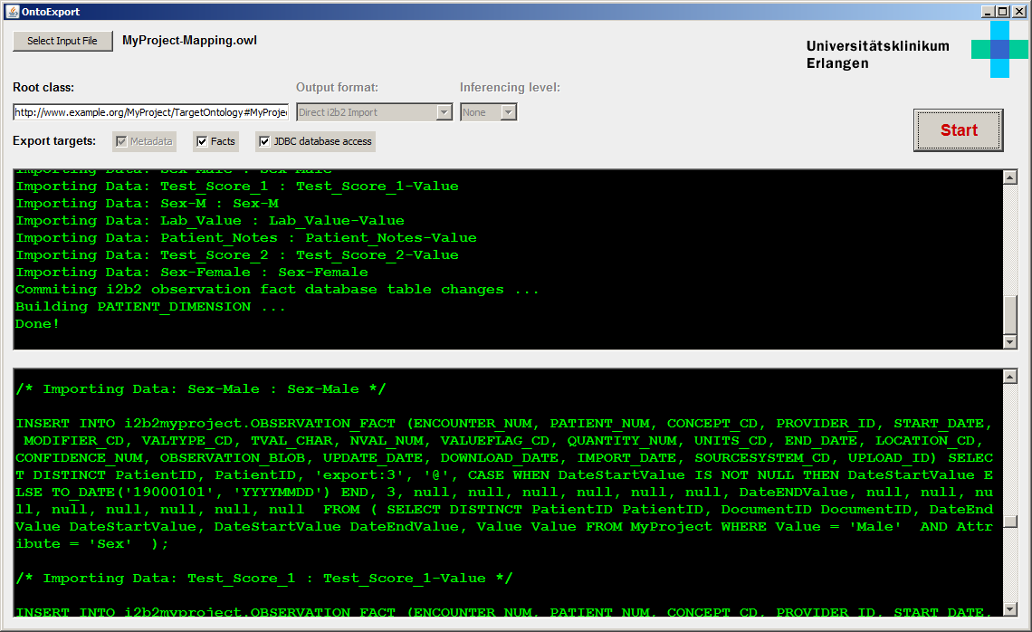

This processes the created ontologies and performs a data import from the “MYPROJECT” table into the i2b2 tables. To check if everything is working, launch i2b2 and log in:

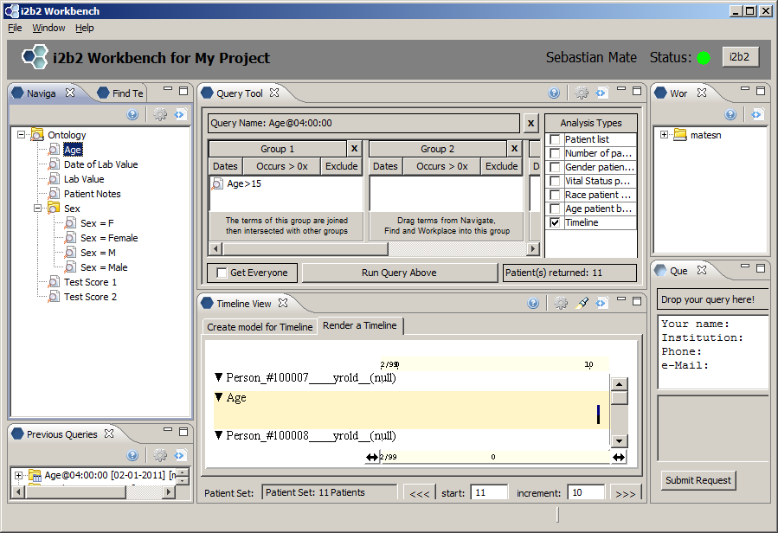

Congratulations, you have successfully imported the data from the CSV file! ☺

The created mapping ontology only contains naïve 1:1 mappings, which correspond to the CSV file’s structure. To demonstrate the mapping capabilities of the system, predefined test mappings are supplied inside the TestMappings subdirectory. Copy the two OWL files from this directory into the main program directory to replace the existing target and mapping ontology.

To edit the target ontology, run OntoEdit.jar and press “Load”. You can use this tool to create/modify concepts inside the target ontology. The right side allows you to enter i2b2-Ontology specific parameters:

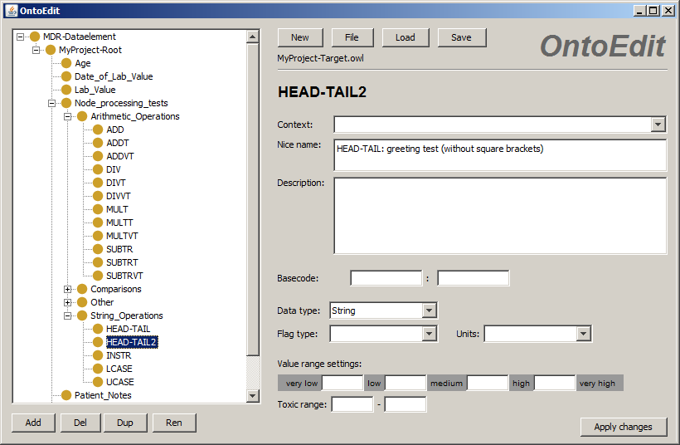

Avoid renaming concepts, because this breaks existing mappings (an “Orphaned Mappings” warning will pop up when you open the ontology in QuickMapp). Exit OntoEdit. To edit mappings, run QuickMapp.jar, press “Open” and “Load Ontology”:

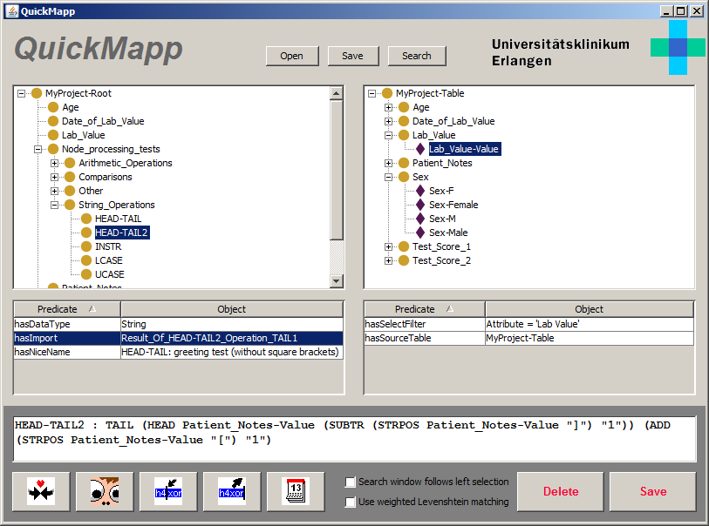

The shown mapping extracts the “greetings” inside the “Patient Notes” column from Input.csv, which can be found between the square brackets (“Hello World”, “Hallo DPKK” and “Huhu IMI”).

Exit QuickMapp and launch OntoExport again, press “Start” to perform the export again. Now i2b2 should now find three patients for the greeting concept:

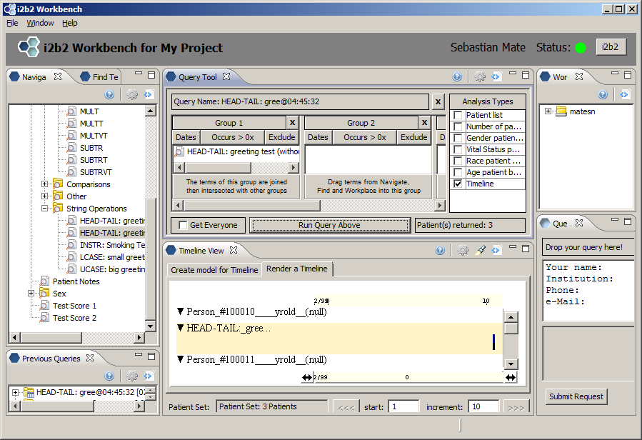

In fact, this gets exported to OBSERVATION_FACT:

